AN E-COMMERCE SALES
DOCUMENTATION

INDEX
- OVER View
- Dataset Description
- Data Modeling
- Dax Expression and Calculations
- Visualization Summary
- Conclusion

1.Overview:
This project involves analyzing an e-commerce sales dataset using Power BI. The goal is to perform data modeling, derive business-critical metrics using Data Analysis Expressions (DAX), and create interactive visualizations to monitor sales trends, target achievements, and regional distributions.
2. Dataset Description:
The analysis uses three primary CSV files:
- List of Orders.csv: Contains order-level data including Order ID, Order Date, Customer State, and City.
- Order Details.csv: Contains itemized transaction data including Category, Sub-Category, Quantity, Amount, and Profit.
- Sales target.csv: Contains target metrics by Category and Target Date.
3. Data Modeling:
Before performing calculations and building visualizations, the following schema relationships were established:
- List of Orders linked to Order Details via Order ID (One-to-Many).
- Sales Target linked to Order Details / List of Orders via Category and relevant Date fields.
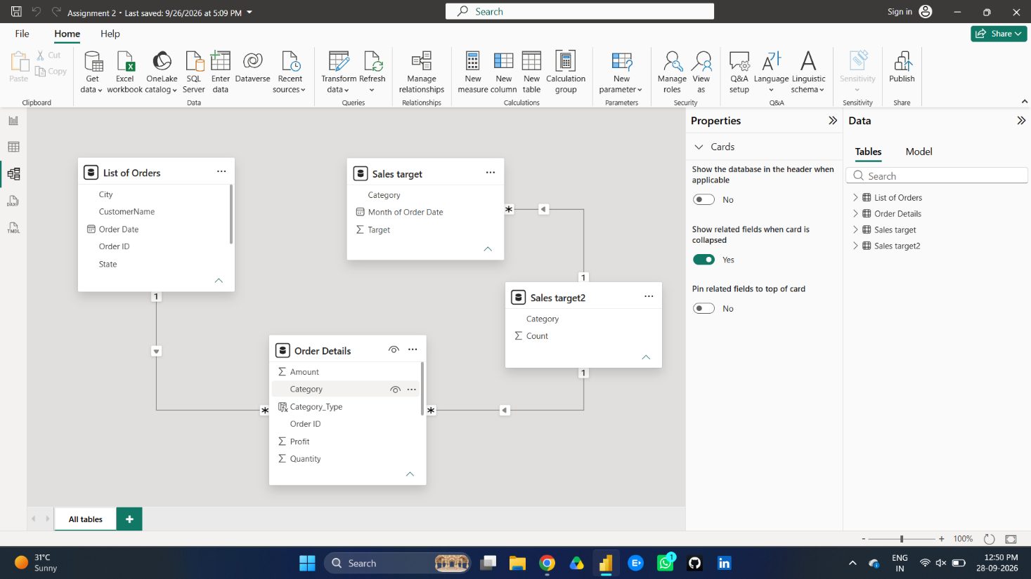
4. DAX Expressions & Calculations:
Calculated Columns (Order Details Table)
- Category Type: Combines Category and Sub-Category for granular grouping.
- Category Type = 'Order Details'[Category] & " - " & 'Order Details'[Sub-Category]
- Revenue per Order: Calculates total revenue generated for each line item.
- Revenue per Order = 'Order Details'[Amount] * 'Order Details'[Quantity]
- Sales Category: Classifies transactions relative to overall average order value.
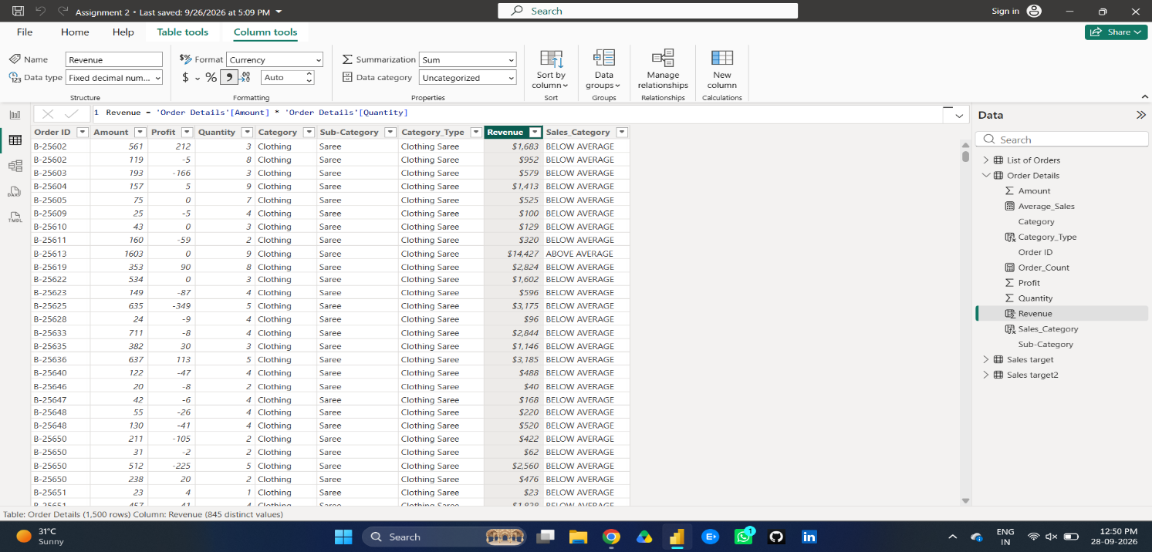
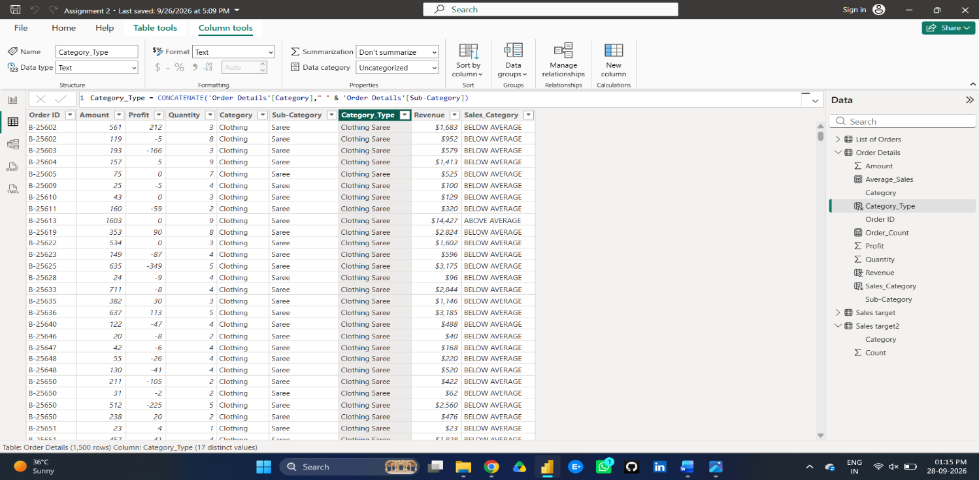
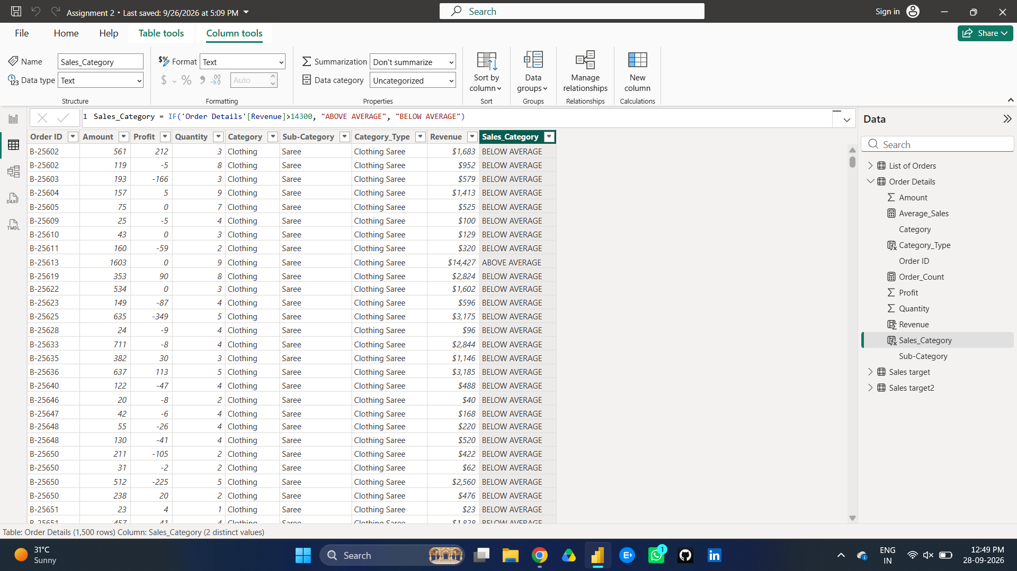
Calculated Measures:
- Total Order Count: Counts total transaction line items.
- Total Orders = COUNT('Order Details'[Order ID])
- Average Profit in Delhi: Evaluates profitability specifically within Delhi.

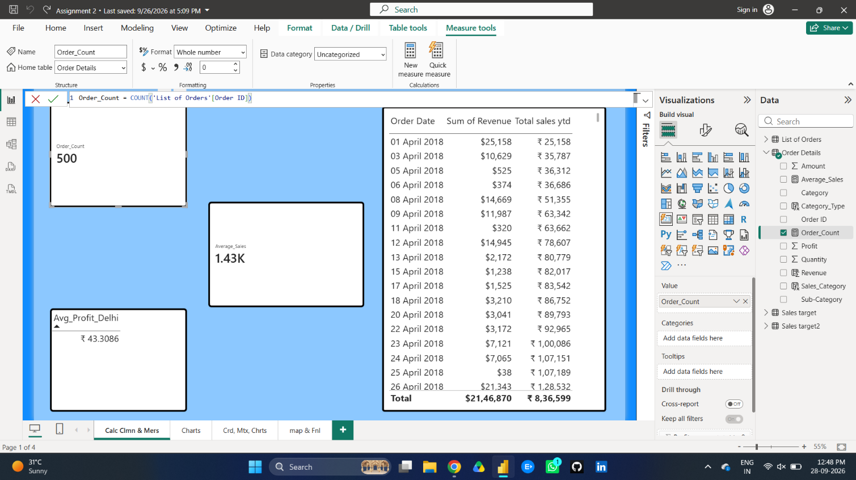
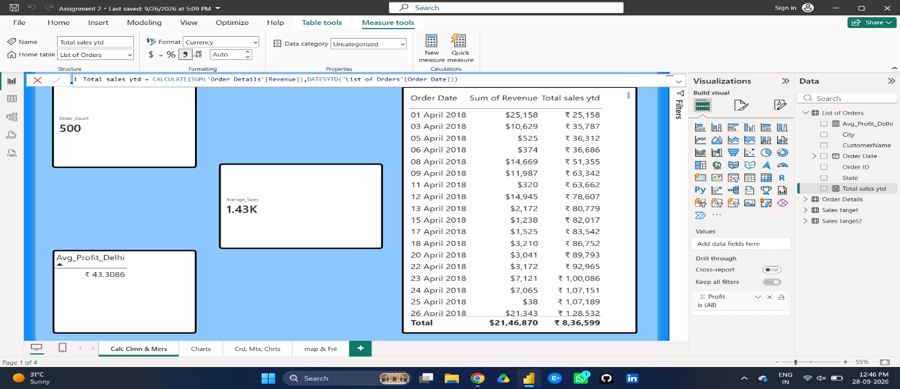
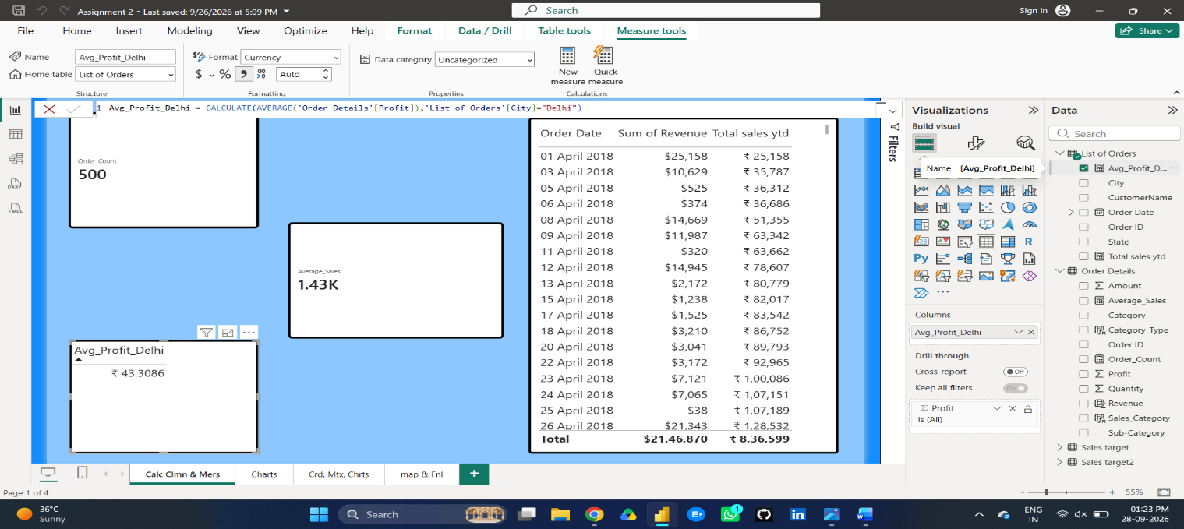
5. Visualizations Summary:
- Sales Target Achievement by Category: Clustered Column Chart comparing actual sales against target sales.
- Max Profit Margin by Sub-Category: Donut Chart displaying top profit contributors by sub-category.
- Monthly Sales Trend: Line Chart illustrating sales trajectory over time.
- Profit vs. Quantity Analysis: Scatter Plot showing correlation between unit volume and profitability by sub-category.
- Key Performance Indicators (KPIs): Single-Value Cards showing Total Sales vs. Target, and Multi-Row Cards displaying minimum segment targets.
- Sales Performance Matrix: Matrix Visual cross-analyzing category performance monthly against targets.
- Geographic Sales Analysis: Map visual highlighting city-wise sales performance.
- Sales Distribution: Treemap displaying sub-category proportion relative to overall sales.
- Order Count Analysis by State: Funnel Chart displaying state-by-state order volumes.
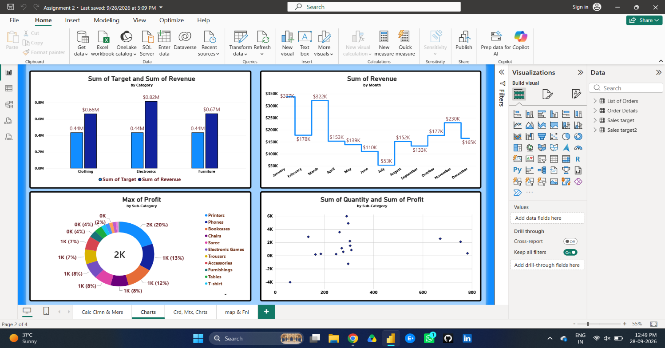
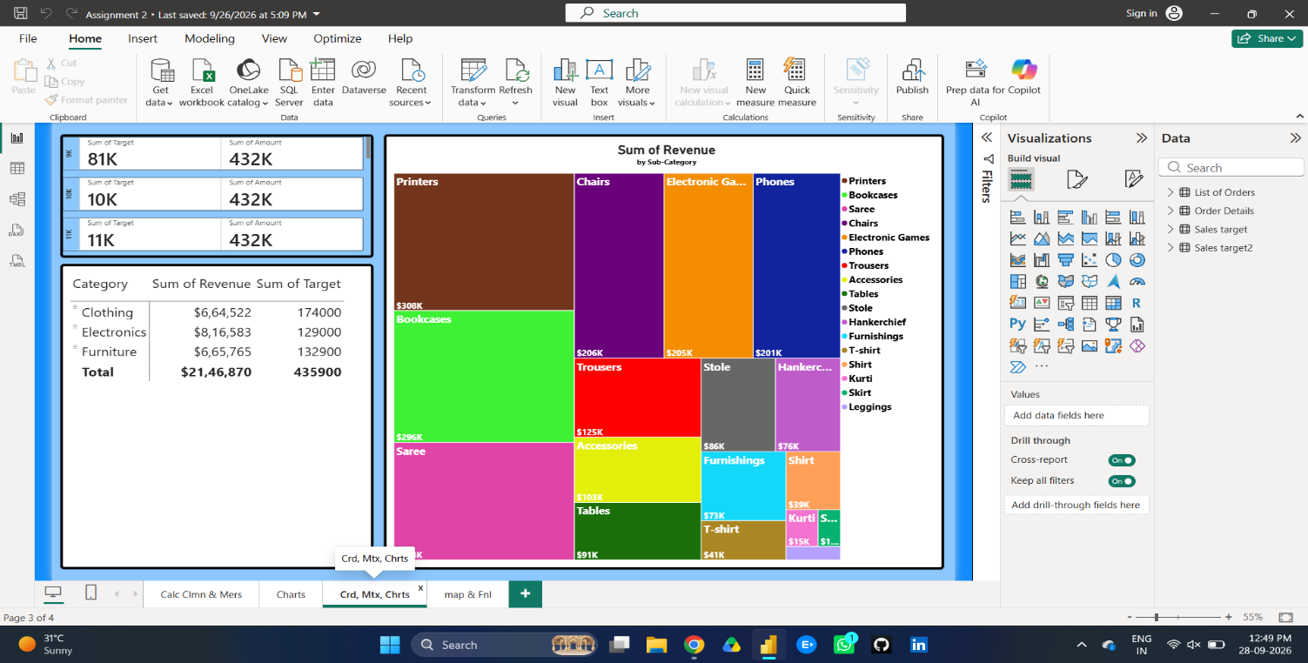
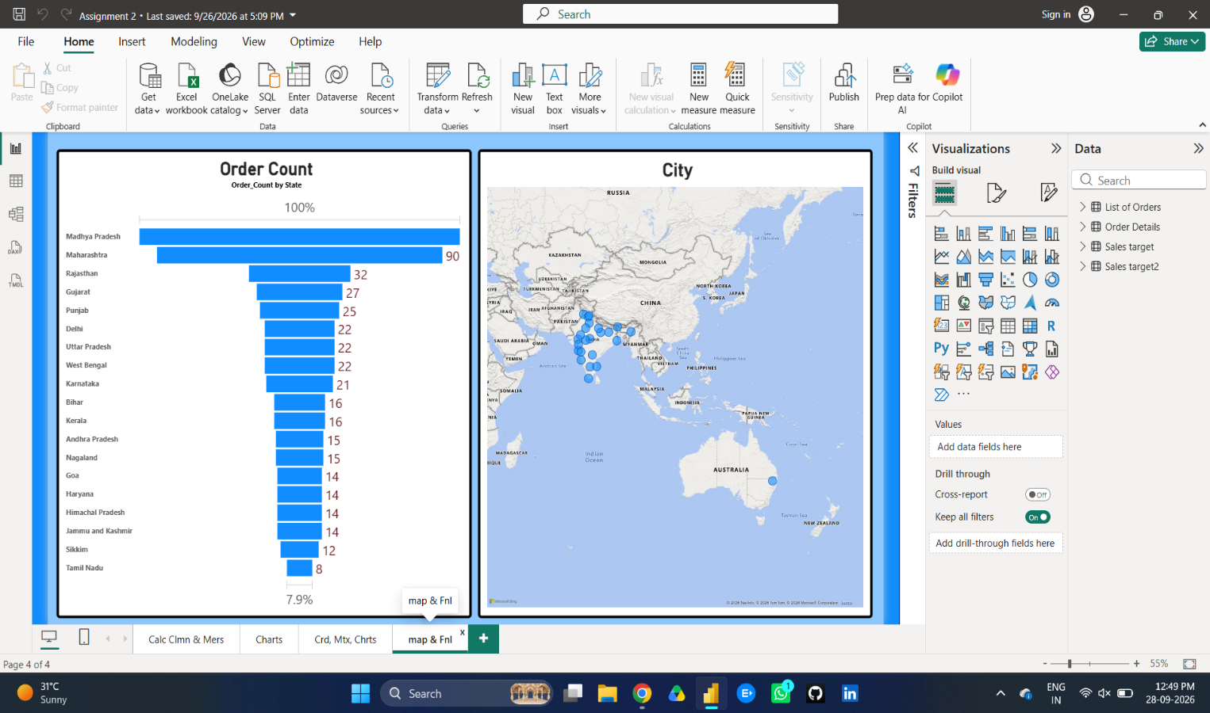
6. Conclusion:
Through DAX calculations and data modeling, this project transforms raw e-commerce transactional data into interactive visual insights. It provides a comprehensive view of sales trends, profit margins, regional demand, and category-wise target achievements to support data-driven decision-making.

